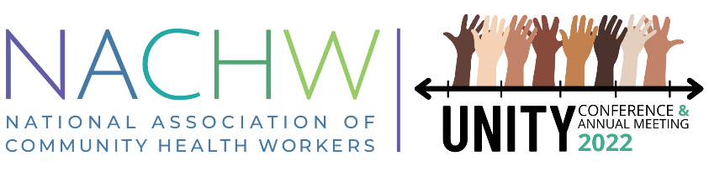
The National Association of Community Health Workers 3rd Annual Unity Conference
----
Community Health Workers: The Past, Present, and Future of Community Care
August 3-4, 2022

Thank you for your interest in applying to be a speaker at the 2022 NACHW Unity Conference! Please complete and submit your application by 11:59 pm EST on June 10th, 2021.
Completed applications should be emailed to unityconference@nachw.org with the subject line, “Call for Presentations Unity 2022.”

Name of Applicant:

Name of Organization:

Organization Website (if applicable)

Applicant Email Address:

Applicant Phone Number:

Applicant City, State, and Zip Code:

Applicant Bio (250 word maximum) (Please include if applicant is a CHW)

Applicant Headshot | Insert here or attach to email
Names and Bios of Other Presenters (if applicable, up-to 3, either the applicant or one of the presenters must identify as a CHW)

Topic Title: (Maximum 20 Words)

Session Abstract/ Description: (Maximum 200 Words)

Session Objectives (What will attendees learn?) Please begin the description of each learning objective with a VERB)

Session Topics (up-to from the list provided in the call for presentations)

How is this topic related to our theme of the Past, Present, and Future of Community Care? (Maximum 200 words)

Please describe how you will create an interactive and highly engaging environment for your workshop attendees in a virtual space. For reference, you will have the following functionality/tools to incorporate into your workshop: Presenter audio and video, chat function, screen sharing, live polling. (Maximum 200 words)

Optional: Upload draft presentation: (.ppt file) | Attach to the email if applicable

Please email the completed application to unityconference@nachw.org with the subject line, “Call for Presentations Unity 2022” by 11:59 pm EST on June 10th, 2021.
We look forward to reviewing your application!

