JULY, 2018

University of South Carolina

South carolina framework for community health worker practice

**Thanks to all the partner organizations who have contributed their time and effort into the development of the South Carolina Community Health Worker Practice framework.**

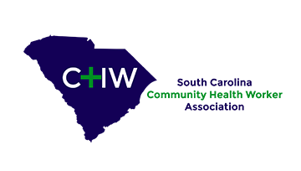

**Report prepared by:**

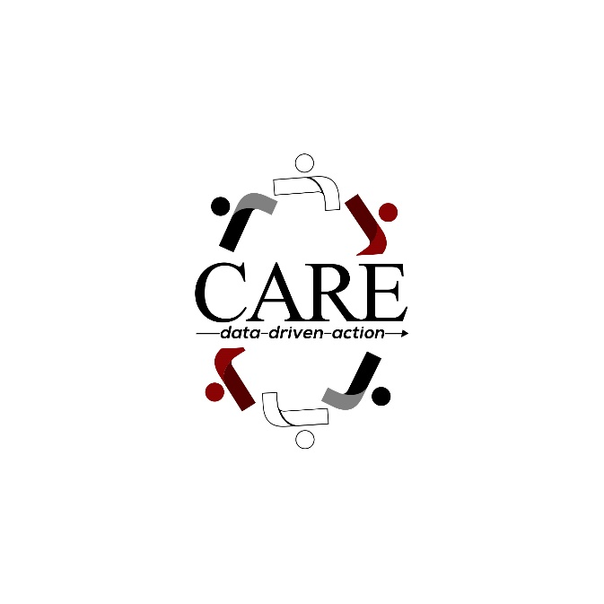

Pamela S. Gillam, MPA

Elijah Christian, MPH

Core for Applied Research and Evaluation (CARE)

Arnold School of Public Health

University of South Carolina

Holly Hayes, MSPH, PMP

Iron Sharpens Iron Consulting Group, LLC

**TABLE OF CONTENTS**

1. **CHW Definition and Titles……………………………………………………………………………………………………………….3**
2. **CHW Scope of Work…………………………………………………………………………………………………………………….….3**
3. **CHW Certification……………………………………………………………………………………………………………..…………….3**
   1. **CHW Training Curriculum………………………………………………………………………………………………………………….3**
   2. **CHW Grandfathering…………………………………………………………………………………………………………………………4**
4. **CHW Training………………………………………………………………………………………………………………………………………………..4**
5. **CHW Continuing Education and Re-Certification……………………………………………………………………………………………4**
6. **CHW Credentialing Council…………………………………………………………………………………………………………………………….5**
   1. **Composition of Council Members………………………………………………………………………………………………………5**
   2. **Funding of the Administration of the Credentialing Council……………………………………………………………….5**
7. **Core Metrics…………………………………………………………………………………………………………………………………………………..6**
8. **Works Cited……………………………………………………………………………………………………………………………………………………8**

List of Figures

1. **Figure 1: Visual of CHW Practice Framework …………………………………………………………………………………………….3**
2. **Figure 2: Program and Core Level CHW Metrics …………………………………………………………………………………………7**

A taskforce was formed in February, 2018 with the goal of developing an over-arching framework for community health workers (CHW) to be fully adopted in South Carolina (SC). A group of internal and external stakeholders met three times to determine what components are necessary for CHWs to be recognized as valuable and integrated members of care teams. Discussions were grounded on key informant interviews with internal and external stakeholders and a document review highlighting national trends and models in other states. The SC CHW Framework Taskforce reached consensus on the components described below. Further discussions are needed to solidify detailed policies, applications, and criteria for some of the components.

Figure 1 depicts the SC Statewide Framework for CHW practice.

Figure 1: Visual of SC CHW Practice Framework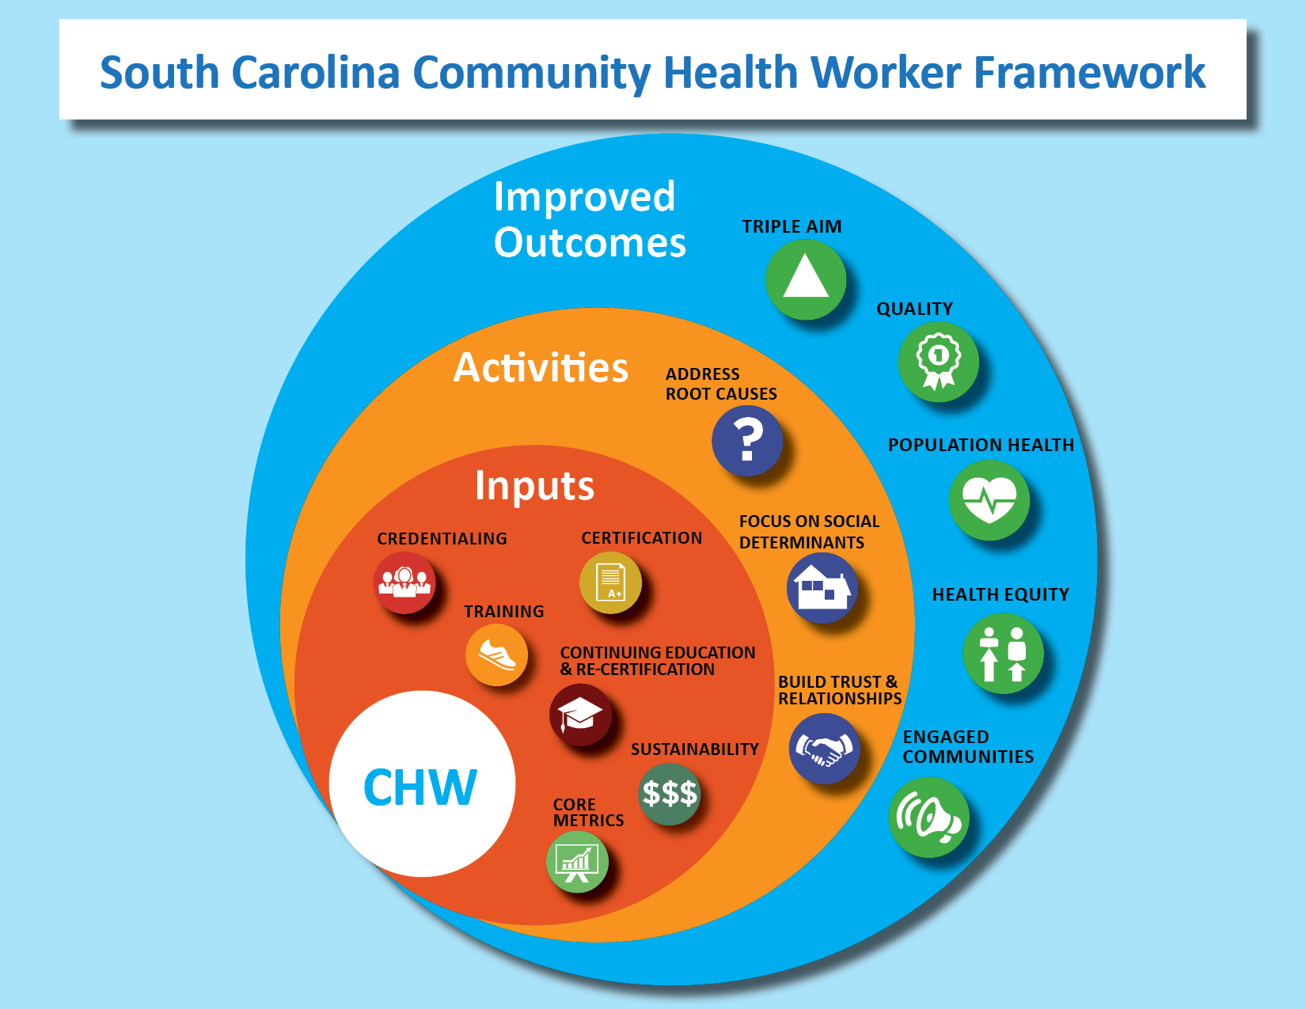

1. **CHW Definition**

Community Health Workers (CHWs) are frontline health workers who may have diverse job titles (such as Promotores, Patient Navigators and Outreach Workers, etc.), they are trusted members of the community

they are serving and/or have a thorough understanding of the community, and are committed to addressing

the health needs of the individuals with whom they are working. This trusting relationship permits CHWs to

connect individuals to health care and social service resources in the community and to improve the quality

and cultural competence of service delivery. CHWs have the capability to address social determinants of health in order to improve health outcomes of the individuals they are serving. CHWs build individual and

community capacity by increasing health knowledge and self-sufficiency through a range of activities such as outreach to individuals in their environment, community education, counseling, social support and advocacy 1.

**CHW Titles**

CHWs in SC have various job titles. Regardless of title, in order to be considered a CHW in SC, individuals must encompass the following:

1. Be a trusted member of the community
2. Have the ability to address social determinants of health
3. Possess the qualities, skills and perform the scope of services of a CHW.

The following are titles are currently included under the SC CHW umbrella: community health worker, health outreach worker, community health advocate, community liaison, health worker, lay health advisor, client navigator, patient navigator, peer counselor, peer educator, promator/a, resource mother, community organizer and case manager. It is important to note that health systems often have their own unique titles for these positions. Some of the titles listed above, may not be reflective of a CHW; the scope of work of the individual matters (i.e. community organizer and case manager).

1. **CHW Scope of Work**

CHWs work with many different types of partners including health care providers, managed care plans, human

service organizations and community-based organizations. Job duties typically involve three main

components: Helping people navigate health care and human services systems; providing culturally

appropriate health education; and building individual and community capacity 2. It can also include care

coordination or case management and advocating for individuals or communities served by the CHW.

1. **CHW Certification**

*CHW Training Program Curriculum.* All CHW training program curriculum should be approved by the SCCHWA Credentialing Council. Organizations that wish to provide a CHW training program must submit an application with a copy of their curriculum for approval. CHWs in SC are required to be trained using the eleven nationally accepted core competencies for CHWs, through an engaged classroom-style process and a fieldwork/mentorship component. The eleven national core competencies2 are:

1. Outreach methods and strategies
2. Client and community assessment
3. Effective communication
4. Culturally based communication and care
5. Health education for behavior change
6. Information about common chronic diseases
7. Support, advocate and coordinate care for clients
8. Apply public health concepts and approaches
9. Community capacity building
10. Writing and technical communication skills
11. Ethics

CHWs must complete a minimum of 80 hours of in-class learning and 80 hours of fieldwork (160 hours total). Following the classes and fieldwork component, an individual needs to pass an exam, which encompasses the eleven national core competencies for CHWs. The exam is currently administered by Midlands Technical College. In addition, each student needs a fieldwork mentor that gives the CHW candidate a favorable on-site evaluation of fieldwork completion. *Currently not in place but guidelines and the application has been drafted.*

A process for certifying CHWs from other states is yet to be determined, but it has been suggested to grant reciprocity for these CHWs if their education covers the core competencies or they need the grandfathering requirements covered below.

**CHW Grandfathering**

Grandfathering will be an option for individuals who have served as a CHW in the community for at least three years and who successfully pass the certifying exam. The number of years for the grandfather clause is being revisited at this time. Supervisors must provide documentation that the CHW seeking certification via the grandfathering option has acquired the requisite CHW core competencies and has served in the community at least five years 3. Individuals who are “grandfathered in” are required to go through two days of training: Day one - Eight hours of approved training & Day two – Four hours of approved training & CHW exam completion.

1. **CHW Training**

All CHW training program instructors must be approved by the SCCHWA Credentialing Council through an application process. Instructor qualifications include: Master’s Degree in Health-Related fields such as Social Work, Social Services and Public Health and must have 5 years community health experience OR a Bachelor’s degree in a health related field with 8 years’ experience in community health and a CHW Certificate. While it is not required for an instructor to be a CHW, it is also national best practice for instructors who are not CHWs to have CHWs co-teach courses with them to ensure accurate information is being taught. *Currently not in place but application and qualifications have been drafted.*

Training for CHW supervisors is needed and in the process of being developed.

Specialized training is also being developed to include both non-medical (walkability, rural, safety in home) and medical specialized training (maternal child health, palliative care).

1. **CHW Continuing Education and Re-Certification**

Continuing education is required for all certified CHWs to maintain certification. CHWs must earn 20 hours of continuing education units every two years5. Continuing education must be approved by the CHW Credentialing Council. Re-certification will be required every two years, with annual dues being paid by January 31st 5. Specialized training is also being developed to include both non-medical (walkability, rural, safety in home) and medical specialized training (maternal child health, palliative care).

*Currently not in place but process and specifications have been drafted.*

1. **CHW Credentialing Council**

*Establishment and Purpose.* The South Carolina Community Health Workers Association (SCCHWA) Credentialing Council is responsible for coordinating activities to establish and administer the policies and procedures for South Carolina (SC) Community Health Worker (CHW) certification. The primary duties of the Credentialing Council include but are not limited to the following:

1. Review and approve SC standards and requirements for certifying CHW Training Programs and Instructors established by the SCCHWA.
2. Certify and recertify CHW Training Programs and Instructors based on the following;
3. the core competencies required for certification;
4. the minimum education, training, experience, and other qualifications to become a certified CHW and Instructor;
5. Approve evaluation tools to assess CHWs and CHW Instructors’ competency for certification.
6. Establish and implement procedures for the investigation and resolution of complaints related to the practice of CHW Training Programs, CHWs and Instructors. Also, to establish and implement disciplinary actions in connection with complaint resolution, which may include a fine, reprimand, probation, censure, or suspension, revocation, or denial of certification.
7. Develop guidelines for reciprocity and grandfathering

*Granting of Authority.* The Credentialing Council will need to be granted authority by an entity to administer the SC CHW Certification Process. The taskforce supports the SCCHWA to be responsible for coordinating activities related to credentialing. In the long term, it is recommended to pursue authorization through the SC Legislature. The legislature will be responsible for identifying and granting authority to the organization who will administer the program.

*Composition of Council Members.* The Council will be a maximum of 15 individuals: eight SCCHWA members & seven external stakeholders. The external stakeholders shall consist of professionals from the following areas:

1. Community organizations working with CHWs
2. Public (state, county or city) organizations
3. Educational institutions (higher education)
4. Business and other industries

SCCHWA members will elect the members of the Credentialing Council (except the initial Council will be appointed by SCCHWA Executive Committee). Council members will serve a term of a minimum of two years. Council members may not send proxies as a replacement in their absense. As members rotate off, new members will be elected by the SCCHWA members.

The members of the Credentialing Council will elect the officers to provide oversight and to manage the duties required of the Credentialing Council. The officers shall include a chairperson, co-chairperson and a secretary. The chairperson will be in charge of creating the agenda and leading the meeting discussions. The co-chairperson will be responsible in absence of the chairperson. The secretary will be responsible for maintaining documentation of the Council’s meeting minutes and scheduling meetings. The Credentialing Council will establish and implement the process for the operations of the Credentialing Council. The Credentialing Council is expected to maintain documentation of all the Council’s meeting minutes.

*Council Member Expectations*

* The members should expect to commit a **minimum of four hours per month** on the Council’s responsibilities. These four hours could include in-person meetings, reviewing documents, emails, phone calls, etc.
* The members will be expected to **meet on a monthly basis for at least an hour** via phone or in-person.
* The members should **meet in-person once a quarter** (at an agreed upon location).
* The members are expected to **attend 80% of all scheduled meetings**.

*Funding for the Administration of the Credentialing Council*. Sustainable funding for the administration of the Credentialing Council is necessary to fulfill its responsibilities as delineated in in Section I. In the short term, it is recommended funding be pursued through grants from foundations or federal funding opportunities, state agencies such as DHEC and DHHS, and insurance companies. In the long term, to sustain these efforts, it is recommended the main source of funds to coordinate the council will come from fees associated with credentialing (i.e. training curriculum certification fees, Instructor certification fees), SCCHWA membership fees and dues, and other sources including from organizations that utilize and employ CHWs, trainers and institutions. An alternative is for the large organizations to invest into the SCCHWA for long-term capacity building.

1. **Core Metrics**

In addition to metrics required for data collection based on funding, setting or population served, there are metrics that should be collected by all programs using CHWs. The following metrics are recommended for data collection across all CHW programs:

|  |  |
| --- | --- |
| **Program Level** | **Individual Level** |
| * Number of patients served * Types of services provided * Number of referrals/referral completion * Patient engagement/”graduation rate” (i.e. point at which CHW care is no longer needed to achieve improvement in health outcomes) | * Demographic information * Health status/conditions * Insurance Coverage * Progress towards individual goals/care plans |

Figure 2: Program and Core Level CHW Metrics

While it has not been decided who should collect this information, it is important to note that any data related to these core metrics should be shared with the following groups:

* + - 1. Funders
      2. Patients (those served by CHWs)
      3. Collaborators/Partners of CHWs
      4. Legislators
      5. The general community/public
      6. Care team members (providers, nurses, MSWs, etc.)

These groups should have access to the core metrics through the SCCHWA webpage, but metrics should also be shared through large group presentations via webinar or conference and also small group presentations to provide greater opportunity for advocacy, education and collaboration.

**Works Cited**

1. South Carolina Community Health Worker Association (SCCHWA). (2016, November 16). *Definition and Scope of Service of Community Health Workers (CHW)*(Rep.). Retrieved April 10, 2018, from SCCHWA Google Drive: <https://docs.google.com/document/d/1KcRP2IyK74JqZheXwAtS_S_GiQKHkZpqKrl935PO40U/edit>
2. Rosenthal, E. L., Rush, C. H., & Allen, C. G. (2016, July). *Understanding Scope and Competencies: A Contemporary Look at the United States Community Health Worker Field*(Rep.). Retrieved May 1, 2018, from Community Health Worker Core Consensus Project (C3) & the Amgen Foundation website: <https://sph.uth.edu/dotAsset/28044e61-fb10-41a2-bf3b-07efa4fe56ae.pdf>
3. South Carolina Community Health Worker Association (SCCHWA). (2016, November 18). *South Carolina Core Competencies for CHWs*(Rep.). Retrieved April 10, 2018, from SCCHWA website: <https://docs.google.com/document/d/1u5QMeDozZynjYrdaih9yWYzVRNtWWCi4DQjA9Mbw6jo/edit>
4. South Carolina Community Health Worker Association (SCCHWA). (2016, November 18). *Grandfathering for CHWs*(Rep.). Retrieved April 10, 2018, from SCCHWA Google Drive: <https://docs.google.com/document/d/10wG7DA8zXO639mhSRoHXlRlCo8Gmf0Fk6SiYUibEm84/edit>
5. South Carolina Community Health Worker Association (SCCHWA). (2016, November). *CHW Certification Requirements 6.14* (Rep.). Retrieved April 10, 2018, From SCCHWA Google Drive: <https://docs.google.com/document/d/1q8EMO9X-drE2GH4a2_-VbcW_Md5-1-Bh1c1L6xIfQ64/edit>