Health Share of Oregon Invests $3M in Community Health Workers
Health Share of Oregon.
Published: 15 August 2017
Like66

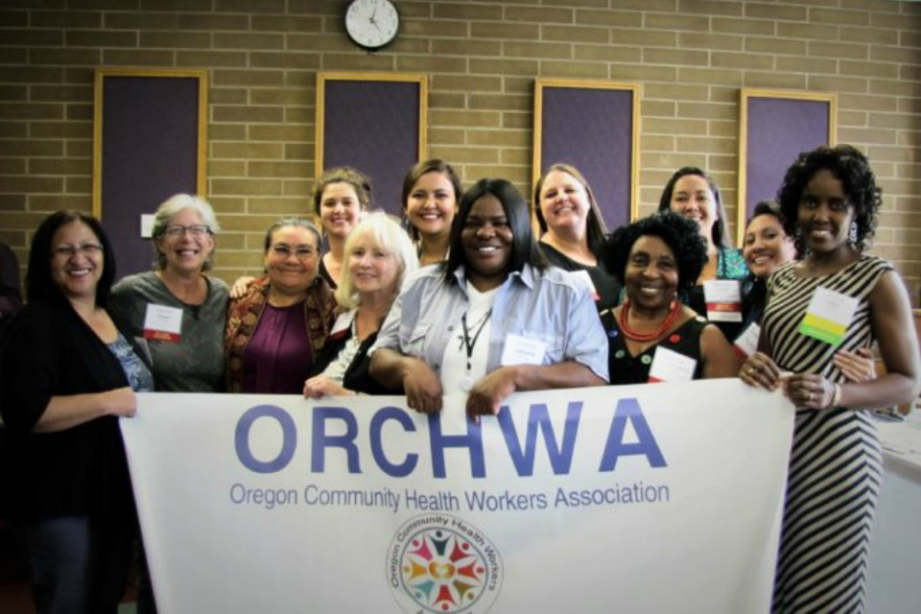
Oregon Community Health Worker Association Board at the 2016 Conference (Courtesy of ORCHWA)
On Thursday, Aug. 24, Health Share of Oregon is hosting a Regional Roundtable to discuss a new $3 million investment in the Oregon Community Health Worker Association (ORCHWA) to increase Oregonians’ access to community-based, culturally specific community health workers (CHWs).
This investment continues Oregon’s leadership in transforming health care, even in the face of threats at the federal level. This event will be held at the Native American Youth and Family Center (NAYA) in Northeast Portland.
Panelists for the Regional Roundtable include State Representative Alissa Keny-Guyer and several leaders in the Oregon health care industry, as well as members of the CHW workforce.

Why:
With threats to health care coverage in the news on a daily basis, many Oregonians are worried about getting the care they need.
This event provides an opportunity to highlight how Oregon is continuing to pioneer new ways to improve access to health care for the people who need it most, and to share stories of an innovative model that is transforming lives through community-based services.

When:
Thursday, Aug. 24, 2017, 3:00 p.m. – 4:00 p.m.

Where:
NAYA Family Center
5135 NE Columbia Blvd
Portland, OR 97218

Who:
Health Share of Oregon and ORCHWA will host the event. Panelists include:
- Janet Meyer, CEO of Health Share of Oregon
- Alise Marie Sanchez (Anishinaabe), Executive Director of ORCHWA
- State Representative Alissa Keny-Guyer
- Marni Kuyl, Director, Department of Human Services, Washington County and Health Share Board Member
- Catherine Potter, Manager Safety Net Partnerships, Community Benefit, Kaiser Permanente Northwest
- Haika Mushi, Community Health Worker, African Family Holistic Health
- Guadalupe Avila, Community Health Worker, Northwest Family Services

More Information:
Many people in the Portland Metro region continue to face significant health and health care disparities.
The CHW workforce has proven to increase access to and improve the quality of health care for the communities they serve. To date, the lack of adequate funding and infrastructure to support training, deployment, and supervision for these workers has prevented this successful model from reaching everyone it can benefit.
Health Share is investing $3M over the next two years to create a sustainable infrastructure that supports CHWs and health systems’ ability to access culturally specific community-based CHWs. Goals of this investment include:
- Enable health systems, health plans, providers and CCOs to efficiently and reliably contract for community-based, culturally specific CHW services.
- Support communities to effectively address disparities, improve health outcomes and reduce costs.
- Increase workforce capacity and employment opportunities for culturally specific community-based community health workers.

About Health Share of Oregon
Health Share of Oregon is the state’s largest Medicaid coordinated care organization (CCO), serving more than 215,000 Oregon Health Plan (OHP) members in Clackamas, Multnomah, and Washington counties. Our mission is to partner with communities to achieve ongoing transformation, health equity, and the best possible health for each individual.
Health Share was founded and continues to be governed by eleven health care organizations serving OHP members: Adventist Health, CareOregon, Central City Concern, Clackamas County, Kaiser Permanente, Legacy Health, Multnomah County, Oregon Health & Science University, Providence Health & Services, Tuality Health Alliance and Washington County.

