Community Health Workers

Acknowledgments

The Oklahoma State Department of Health would like to acknowledge the following individuals and organizations for the assistance and contributions to this work:

Cherokee Nation
Good Shepherd Ministry Free Clinic
Governor’s Council on Workforce and Economic Development Healthcare Workforce Subcommittee
Marshan Marick
Morton Comprehensive Health Services
Oklahoma City County Health Department
Oklahoma Department of Mental Health and Substance Abuse Services
Rural Health Projects
University of Oklahoma Silver Clinic
Tulsa Day Center for the Homeless
Variety Care

Executive Summary

Transitioning health care systems, especially those focused on coordinated, value-based care have opened the discussion on the role Community Health Workers (CHWs) can play in bridging the health care system with the community and social systems that influence population health. Although many definitions and roles for CHWs have been established across the United States (and the world), the general utilization of a CHW is as a trusted member of a community that serves as a link to culturally and linguistically appropriate care and services for patients while providing information and support to health care providers.

In Oklahoma, CHWs are being utilized under different titles in various settings. There is not one specific path for an individual to be educated, trained or work as a CHW nor is there a universal understanding or set of standards for the profession. This report explores the efforts of other states to establish processes to ensure CHWs are a recognized professional in the health care workforce and aid in the development of standards, training programs and credentialing in Oklahoma.

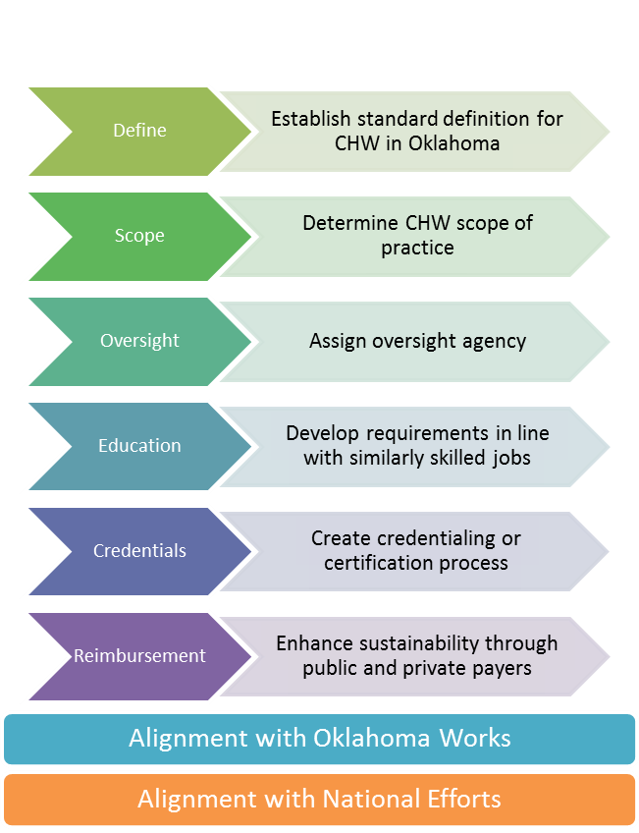
Many factors will need to be considered in order to establish CHWs in Oklahoma. Private and public stakeholders in health care, policy, and the communities being served will need to provide input in shaping the course of developing this new health care profession. Specific steps to be taken will include: defining community health worker; determining scope of practice; assigning an oversight body; developing education and credentialing requirements; and defining reimbursement sources for sustainability.

With Oklahoma’s poor health outcomes and high costs for health care, CHWs seem like a natural fit to help bridge the gap between communities and the health care system in an effort to address health disparities and improve the population’s health. Although there is no standard training or utilization of CHWs in Oklahoma, both public and private health care entities are utilizing CHWs and other health care professionals to assist in reaching the triple aim. This paper will give an overview of known CHW and CHW-type positions being utilized across the state, information on other states with existing standards and regulations establishing CHWs as a health care profession, and recommendations for next steps in furthering CHWs as part of the health care system in Oklahoma.
Overview of Community Health Workers

The use of community health workers (CHWs) and their benefit to both patients and health care professionals has been well documented. Research has demonstrated the use of CHWs around the globe for decades, but more recent changes in health care in the United States, particularly the move to value-based health care, have given rise to a new emphasis on CHWs. Within this new framework, CHWs can be incorporated into health care teams to provide culturally and linguistically appropriate health education, links to health care and social services, and disease prevention services targeted at reducing health disparities and meeting the goals of the health care triple aim – better care, improved health, and lower costs.

Although there is not one standardized definition for CHWs, it is widely understood that the role of a CHW is that of a trusted member of a community who is knowledgeable enough about health and their community’s needs (resources?) to serve as a bridge between patients and health care professionals. Community health workers are not considered clinicians but can be considered in some health care models as a member of the health care team. In Spanish-speaking communities, CHWs are referred to as “poromotres de salud,” or “promotoras,” which is the Spanish term for community health worker. There are several entities that have defined CHW, including:

Health Resources Service Administration (HRSA)
Community health workers are lay members of communities who work either for pay or as volunteers in association with the local health care system in both urban and rural environments and usually share ethnicity, language, socioeconomic status, and life experiences with the community members they serve.¹

American Public Health Association (APHA)
A Community Health Worker is a frontline public health worker who is a trusted member of and/or has an unusually close understanding of the community served. This trusting relationship enables the CHW to serve as a liaison/link/intermediary between health/social services and the community to facilitate access to services and improve the quality and cultural competence of service delivery. A CHW also builds individual and community capacity by increasing health knowledge and self-sufficiency through a range of activities such as outreach, community education, informal counseling, social support, and advocacy.²

Bureau of Labor Statistics (Federal Department of Labor)
CHWs assist individuals and communities to adopt healthy behaviors and conduct outreach for medical personnel or health organizations to implement programs in the community that promote, maintain, and improve individual and community health. They may provide information on available resources, provide social support and informal counseling, advocate for individuals and community health needs, and provide services such as first aid and blood pressure screening. They may collect data to help identify community health needs. Excludes “Health Educators”.³

Affordable Care Act
CHWs are individuals who promote health or nutrition within the community in which the individual resides: a) by serving as a liaison between communities and healthcare agencies; b) by providing guidance and social assistance to community residents; c) by enhancing community residents’ ability to effectively communicate with healthcare providers; d) by providing culturally and linguistically appropriate health and nutrition education; e) by advocating for individual and community health; f) by providing referral and follow-up services or otherwise coordinating care; and g) by proactively identifying and enrolling eligible individuals in Federal, State, and local private or nonprofit health and human services programs.⁴

Depending on a community’s specific resources and needs, the day-to-day duties of a CHW may vary by location; however, the majority of CHWs fall into one or a combination of basic care models.
The 2007 Community Health Worker and National Workforce Study¹ conducted by HRSA outlined the following five models of care:
Figure 1. Community Health Workers link communities to health care
- Member of care delivery team: The CHW is a subordinate to the lead health care provider (physician, nurse, social worker) and specific tasks are delegated by the lead provider.

- Navigator: The CHW assists families in negotiating the complex health care system and improves confidence in patient-provider relations. This model requires the CHW to have a high level of knowledge and understanding of the health care system with a focus on increasing access to primary care.

- Screening and health education provider: This role is typically condition-specific (e.g. diabetes, asthma), and the CHW teaches self-care methods, administers basic screenings, and may take vital signs.

- Outreach, enrollment, and informational: The CHW assists patients in enrollment for eligible benefits and programs including: health insurance, primary care home, and social assistance programs.

- Organizer: In this role, the CHW focuses on specific health issues and promotes self-directed change in a community. This level is typically a volunteer CHW.

Oklahoma Efforts

Although there is no established standard definition or education and certification requirements in Oklahoma, health care entities from free clinics to state agencies are utilizing CHWs and similar staff to meet the needs of their patients. For this report, surveys were sent to organizations that were currently known to be utilizing CHWs to gather an understanding of their job duties and employment requirements. In addition, surveys were sent to Federally Qualified Health Centers and free and charitable clinics in the state. The locations highlighted below are by no means a comprehensive picture of CHWs in the state. However, it does depict a range of current utilization and highlights the need for consensus building in order to establish the profession of CHWs as a sustainable component of Oklahoma’s health care system.

Oklahoma Health Care Authority
Beginning in 2015, the Oklahoma Health Care Authority (OHCA) established the Health Management Program (HMP) for SoonerCare Choice members. Members are included in this program if they 1) have or are at risk for a chronic disease; 2) are at high risk for adverse health outcomes; and 3) have increased likelihood of experiencing a health care crisis. The HMP is established at the offices of participating primary care providers who then have a health coach embedded in their practice. Patients identified as meeting the HMP criteria in each practice receive in-person and telephonic health coaching, educational materials, behavioral health screening and resources, and help locating resources in their community. Although the work of the HMP aligns with some of the typical work of CHWs, the OHCA utilizes Registered Nurses to administer the program. The HMP is evaluated each year on provider and patient adherence to the program by an independent evaluator.⁵

University of Oklahoma Silver Clinic
Community Health Workers are utilized as part of a multi-level diabetes education team and serve as the liaison between the program and members of the African American community in Oklahoma City. The CHWs work out of the clinic and provide both health and social service support for participants. The educational requirement for this position is a high school diploma or General Equivalency Diploma (GED). Personal skills required include good verbal communication and ties to the targeted community. Overall job duties include:
- Acts as a navigator to connect patients to community and professional resources through the community hub
- Administers questionnaires and assists diabetes educators in obtaining baseline information
- Assists patients in accessing the health care system for diagnosis and care
- Follows up with patients in the diabetes education program
- Reinforces diabetes self-management goals and behaviors with patients
- Coordinates patient schedules for diabetes education and other needs with the clinic staff

Oklahoma State Department of Health
Currently, the Oklahoma State Department of Health is utilizing CHWs in Sequoyah, LeFlore, and Lincoln Counties through a federal grant. The CHWs are supervised by health department nurses and assist with chronic disease management for heart disease and diabetes. Training is provided through American Association of Diabetes Educators Para-Professional Level 1 course for Diabetes, Centers for Disease Control and Prevention (CDC) heart disease training for CHWs, access to Healthy Eating Active Living Guide for nutrition and physical activity education, and on-site training through the county health department. The CHWs use this training to assist in disease management, health education, and social support.

Oklahoma Department of Mental Health and Substance Abuse Services
The Oklahoma Department of Mental Health and Substance Abuse Services (ODMHSAS) utilizes both wellness coaches and Peer Recovery Support Specialists, which perform job duties similar to CHW roles. Wellness coach refers to an individual who is actively working on personal wellness and who is designated to collaborate with others to identify their personal strengths and goals within the eight dimensions of wellness (spiritual, occupational, intellectual, social, physical, environmental, financial, and emotional). Wellness coaches must complete ODMHSAS specific training, credentialing, and continuing education.

Under supportive supervision, the Peer Recovery Support Specialist (PRSS) provides peer support services from the perspective of lived experience with a mental health and/or substance use disorder(s). The PRSS serves as a catalyst to fully engage consumers with treatment services, brokers information and resources, and assists consumers with the recovery process through supportive interactions with clinical staff and a variety of community stakeholders. Peer Recover Support Specialists are required to have at least a high school diploma or GED and must complete training and a certification exam.

Both positions require supervision by a program manager and may perform work duties in patient homes, a clinic or other health center, or community centers. Currently, ODMHSAS utilizes a combination of agency funds, grants, and Medicaid reimbursement to support both the health coaches and Peer Recovery Support Specialists.

Oklahoma City County Health Department
The Oklahoma City-County Health Department (OCCHD) utilizes 13 CHWs to serve residents of Oklahoma County. CHWs work in the following OCCHD programs:

My Heart: The My Heart program is a collaborative effort between OU Physicians Community Clinic (OUP), North Rock/ Hope Pharmacies, and OCCHD. The My Heart program was developed as a comprehensive cardiovascular risk reduction effort, designed to reduce the burden of cardiovascular disease in the most impacted areas of Oklahoma County. The target population for this program is Oklahoma County residents between the ages of 20-64, with no primary care physician, who have or think they may have diabetes, high blood pressure, high cholesterol, and/or are overweight or obese. The CHWs duties/activities currently performed include conducting assessments to determine the client’s health and social support needs, conducting health screenings, providing basic health education/information, educating the client about resources in the community and linking him/her to needed services, providing translation/interpretation, conducting home visits, promoting My Heart program in the community, providing reminder and follow up calls for doctor visits, helping to address any barriers that may arise with making it to a clinic appointment or other community services the client is provided, and building relationships with community partners and agencies.

Health at School: The Health at School program utilizes the Whole School, Whole Community Whole Child (WSCC) model to address health for students and families. The WSCC model includes 10 different components that relate to health (nutrition environment and services, physical education and physical activity, family engagement, community involvement, employee wellness, health education, health services, social and emotional climate, counseling, psychological, and social services, and physical environment) and guide programming and activities implemented within schools. The target population for this program is children in school and their families that reside in Oklahoma County. The CHWs duties/activities currently performed include conducting assessments to determine the client’s health and social support needs, conducting health screenings, providing basic health education/information, educating the client about resources in the community and linking him/her to needed services, conducting home visits as needed, assisting schools with family engagement activities including health fairs, and building relationships with community partners and agencies.

Hospital pilot: This project proposes to evaluate the CHW program in Oklahoma as a mechanism to improve the quality, efficiency, and value of public health delivery as an integrated component of emergency and acute care settings. INTEGRIS, Mercy, and St. Anthony Hospitals are working in close partnership with the OCCHD to evaluate the effectiveness of CHWs in emergency department settings. Specifically, the purpose of the project is to determine the efficacy of CHWs as it pertains to chronic disease prevention and management. It also seeks to provide support for the CHW role as a cost-effective addition to traditional care teams. The target population for this pilot is uninsured Oklahoma County residents between the ages of 18 – 64, with at least two non-urgent hospital emergency department visits in the past 12 months from date of pre-enrollment and presence of at least one additional risk factor as defined by OCCHD’s risk stratification matrix. The CHWs duties/activities currently performed include conducting assessments to determine the client’s health and social support needs, conducting health screenings, providing basic health education/information, educating the client about resources in the community and linking them to needed services, providing translation/interpretation, conducting home visits, providing follow up calls to ensure clients are able to access resources and to assist with barriers that may arise, and building relationships with community partners and agencies.

The OCCHD CHW’s educational requirements include having a high school diploma and receiving a CHW certificate within 12 weeks of employment. The certification was created by OCCHD and Langston University. Annually, the CHWs are required to attend a one week refresher training conducted by OCCHD. Specific on-the-job training includes blood borne pathogens, health screenings, CPR, home visit safety training, urgent care vs. ER, goal setting, motivational interviewing, cultural humility, and health literacy. The CHWs are supervised by the CHW Coordinator and Community Health Administrator. The CHW position is agency funded.

Tribal
Cherokee Nation covers a 14-county tribal jurisdiction and utilizes CHW-type professionals in their health system. They utilize health educators to assist with programs that address risk factors for chronic disease including physical activity, nutrition, and tobacco free environments. The health educators also conduct referrals and assessments, teach classes and lead support groups, and make referrals to services. Tribal-led efforts in Oklahoma are not currently aligned with the Indian Health Service’s Community Health Representative Program.

Federally Qualified Health Centers
Morton Comprehensive Health Services (Tulsa Metro Area) established one of the first Promotora programs in the area to promote women’s and teen-friendly health. The outreach and education goals include educating diverse and underserved communities on healthy lifestyles and preventive health practices, and collaborating with community partners to achieve overall population health and well-being.

Free and Charitable Clinics
Good Shepherd Ministries of Oklahoma utilizes medical professionals and health care students to provide prevention, wellness, and sick care to low-income, uninsured people throughout central Oklahoma. In addition to doctors, nurses, and dentists, Good Shepherd also utilizes peer support professionals and health educators to assist their patients. These professionals assist in translation and interpretation, peer support and education, and making referrals to other services. All efforts are administered by the Good Shepherd Clinic and are funded through grants and other non-insurance sources.

From these different health care settings, it is apparent that several levels of health care professionals are being utilized to fill CHW-type roles. For Oklahoma to establish CHWs as a stand-alone, recognized, and sustainable health care profession, it is important to define the position and its scope of practice. In this way, higher level professionals, like Registered Nurses, can perform job duties at a higher level of clinical care while allowing CHWs to fill in the need for general health education and social support.

State and National Efforts

Community Health Workers offer an opportunity for states to address their specific needs related to health care transformation and improving population health. States are utilizing various levels of structure regarding CHW roles and regulations in ways that fit their specific population needs. The information below highlights efforts in several states where a professional definition or role, education and certification requirements, and reimbursement methods have been established, either through legislation or governing bodies. In addition to individual state efforts, The Community Health Worker Core Consensus (C3) Project will be discussed to understand work to coordinate CHW efforts on a national level.

Figure 2. Community Health Worker Statutory and Agency Program Requirements
Source: ASTHO⁶

Minnesota
Minnesota has one of the most developed and recognized CHW programs in the United States which is organized through the Minnesota Community Health Worker Alliance and overseen by the Department of Human Services. In Minnesota, CHWs are defined as “trusted, knowledgeable frontline health personnel who typically come from the communities they serve…and bridge cultural and linguistic barriers, expand access to coverage and care, and improve health outcomes.” Certification is required for CHWs to be reimbursed by Medicaid; certification can be supplanted by five years of supervised CHW experience. Minnesota also offers a 14 credit hour education program that is offered through state colleges and includes both classroom and field-based instruction. Supervision must be provided for CHWs and can come from physicians, advanced practice registered nurse (APRN), dentists, certified public health nurses, or mental health professionals. Currently, 15 other states have organizations that are utilizing Minnesota’s CHW curriculum.^{7, 8}

Ohio
In Ohio, CHWs are overseen by the Board of Nursing and are allowed to provide a narrow scope of medical services when directed and supervised by a registered nurse. The Nursing Board defines CHWs as, “individuals who, as community representatives, advocate for individuals and groups in the community by assisting them in accessing community health and supportive resources through the provision of such services as education, role modeling, outreach, home visit, and referral services." Training programs must be approved by the state and include 100 classroom hours and 130 clinical hours; this curriculum includes more medical content than most other states. A training exam must be passed to receive certification. At this time, there is not a current Medicaid reimbursement mechanism for CHWs in Ohio.

Texas
Texas defines its CHWs as a, “Promotora… (which) means a person who, with or without compensation, provides a liaison between health care providers and patients through activities that may include… assisting in case conferences, providing patient education, making referrals to health and social services, conducting needs assessments, distributing surveys to identify barriers to health care delivery, making home visits, and providing bilingual language services.” In Texas, the Department of State Health Services establishes and operates training of 160 hours and certification for CHWs. Like Minnesota, Texas requires completed certification for CHWs to be reimbursed; certification is not required for volunteer activities.¹⁰

Indian Health Services
Indian Health Services (IHS) has been utilizing community health workers, known as community health representatives, for decades. A Community Health Representative (CHR) is defined as “well-trained, medically guided tribal or Native community-based health care provider who may include traditional Native concepts in his/her work.” Funding for CHRs is provided through IHS appropriations. The Indian Health Manual outlines specific policies, procedures, and services for CHRs, but tribes may add additional responsibilities based on their community’s needs.

The role of a CHR goes beyond a traditional CHW in that they are often thought of as a first responder in medical emergencies and can provide more clinical health care services. Some of these clinical services include disease control and prevention through blood testing and immunizations, tobacco cessation counseling, and family planning services. Community Health Representatives are required to take a basic training course or complete a challenge test. Advanced and specialized trainings are also available and a refresher course is required every 36 to 48 months.¹¹

Community Health Worker Core Consensus (C3) Project
The C3 Project is coordinated by the University of Texas Houston’s School of Public Health Institute for Health Policy and is working to expand on previous CHW efforts from the APHA, National Community Health Advisor Study (1998), HRSA’s National Workforce Study, and the CHW Education Collaborative. Within this project, research has been conducted on states currently implementing formal and informal CHW education and certification efforts. Through this research, a clear picture of the trends in CHW establishment across the nation has been formed and many agree on the need for consensus building around CHWs in order to establish them in the health care realm.

While the C3 project does not dictate exactly how CHWs should be utilized, it does recommend the national adoption of the APHA’s definition of CHWs to ensure clarification of the position. In addition, this project is working to build consensus on the skills and qualities CHWs should have, in order to establish a basic understanding for potential employers. In July of 2016, the C3 Project team published its recommendations and is currently taking comment from stakeholders on the future direction of research and alignment of CHWs across the United States. As Oklahoma looks to establish its own CHW program, it will be important to stay informed of the endorsement and adoption of C3 recommendations and consensus building to ensure that Oklahoma’s CHW workforce is in line with others across the nation in order to build up the profession to ensure accurate professional recognition that allows for sustainable reimbursement.¹²

Evidence Base
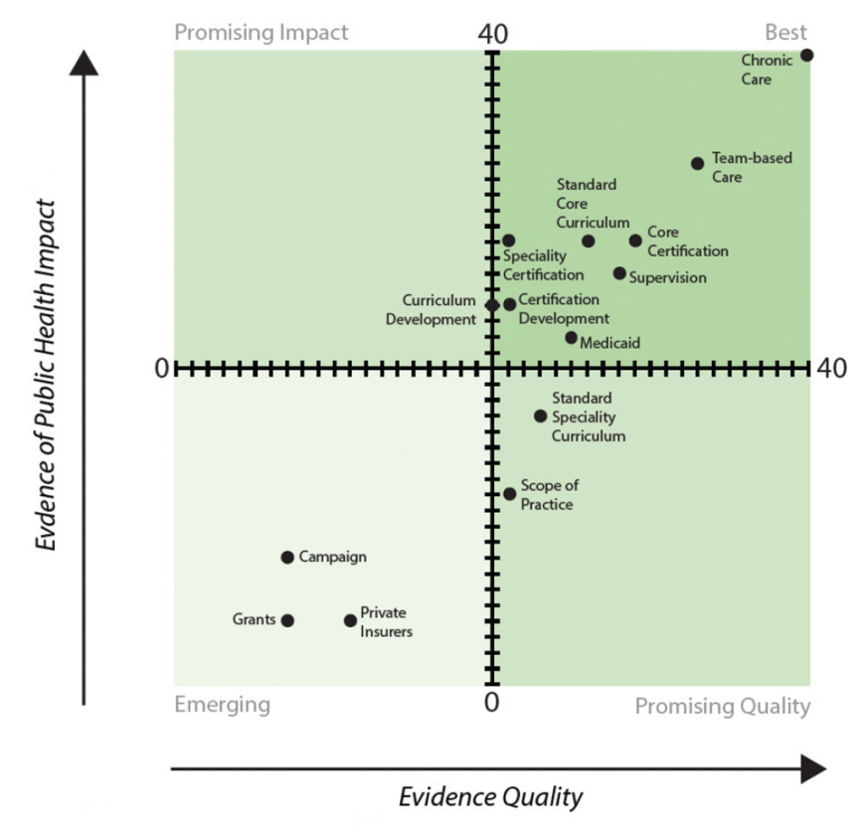
Figure 3. CHW Policy Component Evidence Strength
Source: Centers for Disease Control and Prevention¹³
The Centers for Disease Control and Prevention (CDC)¹³ developed a Policy Evidence Assessment Report evaluating the evidence-base around CHW interventions and policies. Evidence-based components of CHW policy were evaluated using the Quality and Impact of Component (QuIC) Evidence Assessment method which categorizes items from Emerging, Promising Impact, Promising Quality, to Best. “Best” includes evidence from research and practice.

In this review, the CDC denoted the following policies and interventions for CHWs as “best” in relation to patient health outcomes:

- Chronic Care: Evidence suggests that CHWs can improve chronic disease health-related outcomes through improved access to care, disease self-management, social outcomes, increased utilization of lower cost health care, and addressing health disparities.

- Team-based Care: CHWs offer a lower cost health care professional who can improve health outcomes related to patient health disparities when incorporated into a care team.

In relation to the development of the CHW profession, the CDC recognized establishing core certification and curriculum; requiring CHWs to practice under practitioner supervision; including CHWs as reimbursable Medicaid providers; and including CHWs in certification development as having the best evidentiary support. Also noteworthy from the CDC’s assessment is the inclusion of CHW reimbursement under private insurance which can increase the pool of employers CHWs can work for and therefore increase their population reach. The CDC also identified development of an educational campaign to promote CHWs, which can promote demand for CHWs in the health care workforce.

In addition to the CDC, the Community Prevention Task Force, an independent panel that makes recommendations for health improvement, recommends that CHWs be included in chronic disease care. Their research highlighted that CHWs helped improve blood sugar control and weight-related outcomes in diabetes patients. In addition, the task force also noted that CHWs engaged in team-based care models improved blood pressure and cholesterol in patients at risk for cardiovascular disease.¹⁴

The majority of evaluation and research around improved health outcomes, cost savings, and return on investment for CHWs is specific to the intervention for which the evaluation was completed. As such, outcomes from one implementation of CHWs cannot be guaranteed for any other application. However, there are themes in the research which outline the possible impacts CHWs can have on populations and health systems.

In a review of literature for the Legislature, the Massachusetts Department of Public Health¹⁵ compiled findings from studies on CHWs to outline how they can impact health disparities, cost, and quality of care. The focus populations for all studies involving CHWs were low-income, uninsured, insured under Medicaid, and/or using public health centers or hospitals. The overall review of literature found the following CHW intervention impacts:

- Improved access to health care through insurance enrollment and maintenance of current insurance
- Increased utilization of primary care services resulting in decreased emergency department use, which also resulted in health care cost savings
- Increase in preventive services including cancer and chronic disease screening
- Better self-management of chronic disease
- Improved caregiver mental health

Next Steps and Considerations
Figure 4. Steps to Establish Community Health Worker Profession in Oklahoma
The Institute of Medicine¹⁶ reported in 2002 that inconsistent scope of practice, training, and qualifications; lack of sustainable funding; and insufficient recognition by health care professionals were all barriers to the full integration of CHWs into the established health care system. As discussed, many states have been working towards better integration and utilization of community health workers through legislation and policy; training and education; and credentialing and reimbursement. In order for Oklahoma to realize the population health and reduced health care cost benefits of CHWs, these areas will need to be addressed as well. The following section will outline the specific areas for consideration by stakeholders across the state, including current individuals serving in CHW roles. For all decision points, it is critical to consider current efforts for CHWs nationally through the C3 Project as well as state workforce efforts included in Oklahoma Works.

Establish a definition for Community Health Workers. The first step in establishing CHWs in the health care system is determining the state’s definition of a CHW. As noted in previous sections, different efforts and organizations have created definitions for CHWs. Many states have adopted one or a combination of several of those definitions. Some states have also created their own definition. The trend seems to follow the utilization of the APHA definition of CHW, which is also the definition chosen in pursuit of national consensus through the C3 Project. This definition will also assist in more accurate evaluations of CHW supply and demand in the state.

Determine CHW Scope of Practice. After a definition is established, it is essential to define what role CHWs will play in the health care system and what their scope of practice will be, especially in relation to other health care professions. Findings from other states have shown that CHWs can be an essential member of a health care team, so it will be important to define where CHWs fit into teams in Oklahoma. CHWs will provide services in various settings like hospitals, public health departments, and even patients’ homes. In most cases, states utilize CHWs in a role that does not include any clinical services, although some allow for minimal clinical service provision. If any level of clinical service is provided by CHWs, Oklahoma will also need to determine what type of health care provider has oversight or supervision of the CHW. Figure 5 outlines how CHW roles can be defined within the health care system at each level of prevention. As health care moves into better coordination of traditional health care and public health to manage population health, CHWs can provide an important bridge between prevention in traditional health care settings and the patient’s community and home setting.

Figure 5. Community Health Worker Utilization at Differing Levels of Prevention
Definition of Goals
Illustrative Roles
Targeted Client Population
Likely Employers
Source: Adapted from The Urban Institute¹⁷

Identify Responsible Agency. In all states currently educating and/or certifying CHWs, there is a designated oversight body that may establish and approve training and education programs, certify CHWs, or establish a profession registry. The majority of states establish the CHW program through their State Health Department with direction provided by a professional association; other states utilize their Department of Human Services or Nursing Board. In 2011, Oklahoma Senate Bill 882 would have established CHWs under the Oklahoma Board of Nursing and also would have created the Community Health Advisory Board to assist in certification efforts. The bill did not make it through the session to be enacted. It will also need to be determined if the duties of establishing CHW benchmarks, certification, and other oversight duties will be legislatively mandated or not.

Establish Education Requirements and Curriculum. Most states utilize a professional or advisory board when adopting rules and policies impacting CHWs. These boards typically include a variety of public and private health care stakeholders, government officials, and CHWs who are currently practicing in some capacity in the state. Specific duties of each state’s boards may vary, but overall they assist in establishing the CHW profession through determining education and credentialing procedures; promoting demand for the profession through outreach and advocacy; and encouraging inclusion of CHWs in health care transformation efforts and reimbursement models. It is also important to include potential employers in the establishment of educational courses and requirements to ensure that CHWs are receiving training and skills that health care systems have a demand for to increase the likelihood of employment when training is complete. The state will also need to determine if continuing education and re-certifications processes will be required.

Create Credentialing Process. Most states have a credentialing or certification process for CHWs, especially to establish them as health care professionals who can be reimbursed by Medicaid and other insurance payers. At this time, CHWs do not require specific licensure because their scope of practice does not include clinical services that would pose a significant risk of harm to the public. Whether or not to require certification for CHWs will also need to be considered. There are distinct advantages to mandatory certification like easy recognition for CHWs as professionals, establishment of requirements, and increasing professional value. However, required certification can also create cost and language barriers to the same individuals that would be the target population to become CHWs.

In Oklahoma, the State Department of Health is currently responsible for the credentialing and registry process of other health care professions including nurse aides and emergency medical technicians. It is important to consider existing health care professions that are similar in education and skill requirements to ensure alignment with established professions. The following table compares CHWs to similar level health care professions including certified nurse assistants, home health aides, and medical assistants.

Community Health Workers Compared to Other Front Line Health Care Professionals
 | Work Settings | Formal Training | Duties | Average Hourly Wage
Community Health Worker | Community clinics, health departments, hospitals and integrated health systems, schools, social service agencies and other non-profits, housing providers. | Varies from on-the-job to community college certificate programs. HS Diploma or GED required by many employers.  No standard national curriculum.  Certification required for Medicaid reimbursement in some states. | Supervision varies depending on worksite.  Culturally appropriate preventive services, patient education, outreach, and information/referral.  Basic health screenings including vital signs.  Administrative duties including paperwork and insurance forms.  CHW is not a clinician and does not typically provide “hands on” care. | $12.00-$13.00 per hour
Certified Nurse Assistant | Hospitals, nursing homes, and residential care facilities. | Community colleges, vocational schools, technical schools, or universities. One-year program typically leading to a certificate or diploma.  Certification required for Medicare & Medicaid reimbursement. | Supervised by licensed nursing staff.  Assistance with activities of daily living (ADLs)  Maintain patient health records.  Monitors changes in patient conditions | $13.35 per hour
Home Health Aide | Homes and residential care facilities. | No formal education requirements. | Supervised by care manager.  Assists with ADLs &  light housekeeping.  Simple rehabilitative and lifestyle counseling. | $9.70 per hour
Medical Assistant | Ambulatory settings such as provider offices, urgent care, and outpatient clinics. | HS diploma or GED.  Community colleges, vocational schools, technical schools, or universities. One-year program typically leading to a certificate or diploma. | Supervised by MD.  Client history, vital signs, phlebotomy, & injections.  Administrative duties, appointment scheduling, hospital admissions, prescription refills. | $13.87 per hour
Source: CommunityHealth Works¹⁸

Identify Funding Sources. Current CHW efforts in Oklahoma are funded through dedicated organizational resources and grants; there is no reimbursement mechanism through Medicaid or private insurance carriers at this time. There are several funding sources available to reimburse for CHW services that would allow their efforts in assisting with health care transformation to become more sustainable. Under the current fee-for-service reimbursement structure, it is challenging to cover CHW-type services because they are not necessarily linked to a specific procedure with a billable code. However, under emerging health care payment models, like Accountable Care Organizations and other systems with global payments, there is more flexibility to include care coordination services performed by CHWs under a patient’s global payment. Medicaid has also established several options to support financing CHWs including 1115 Demonstration Waivers which allow states to test, or demonstrate, new models; State Plan Amendments which allow for long-term changes in service coverage; and managed care which provides global, capitated payments for patients regardless of specific services received.

Evaluating Value and Benefits. As discussed previously, there is not a consistent research base to definitively say what return on investment or improvements in health outcomes will arise from establishing CHWs as a key professional in the health care system. Therefore, it will be important for stakeholders working on furthering CHWs to consider how to evaluate the value and benefit of establishing CHWs as a health care profession in Oklahoma. This evaluation will also help to maintain adequate demand for CHWs from health care providers and systems as well as ensuring adequate education and training programs exist to create the supply of CHWs needed. Consideration should be given to developing evaluation methods for population health outcome improvements, health care savings, and improvements in cultural competency for providers. In addition, it would be beneficial to establish a clearinghouse where information, lessons learned, and best practices for establishing and utilizing CHWs in Oklahoma can be accessed by those interested in setting up or expanding CHWs in a health care system.

CHWs also should be evaluated as part of a coordinated, multi-disciplinary health care team, as CHWs do not function independently but under the direction of the care team. The CHW should be the intermediary that implements the team’s care plan while addressing the goals and wishes of the patient. In addition, the CHW, who is knowledgeable about the patient’s environment, can provide context to the care team on which interventions are most likely to improve the patient’s health. Establishing the CHW profession will help develop professional recognition, but health care systems will still need to work to integrate CHWs into care teams in order to realize their full benefit. Figure 6 from Community Health Works visualizes the role of the CHW in the broader context of multi-disciplinary, coordinated care.

Figure 6. Community Health Workers within Coordinated Health Care
Source: CommunityHealth Works¹⁸

Conclusion

Oklahoma faces many health challenges related to poor health outcomes, lack of access to services, and shortages of health care professionals. Community Health Workers can serve as a bridge between the health care system and community resources in an effort to improve population health in the state. In order to do this, Oklahoma should develop a coordinated effort amongst public and private stakeholders to develop an infrastructure for the establishment and development of the profession of CHWs in the state. Stakeholders will need to understand the current national landscape of CHWs in order to incorporate strengths and lessons learned in establishing CHWs through regulation, oversight, training, and integration into the healthcare system. Oklahoma has an opportunity to capitalize on the current momentum around CHWs as long as the state can establish an environment that will develop, support, and sustain them.
Citations

1. U. S. Department of Health and Human Services Health Resources and Services Administration, Bureau of Health Professions. (2007). Community Health Worker National Workforce Study.

2. American Public Health Association. Community Health Workers. Retrieved rom: https://www.apha.org/apha-communities/member-sections/community-health-workers.

3. United States Department of Labor Bureau of Labor Statistics. Standard Occupational Code Classification: Community Health Workers 21-1094. Retrieved from: http://www.bls.gov/soc/2010/soc211094.htm.

4. The Patient Protection and Affordable Care Act. Retrieved from: https://www.hhs.gov/healthcare/about-the-law/read-the-law/.

5. Oklahoma Health Care Authority. Health Management Program FAQs. Retrieved from: https://www.okhca.org/providers.aspx?id=8680&terms=health%20management%20program.

6. Association for State and Territorial Health Officials. (2015). Community Health Workers (CHWs) Training/Certification Standards: Current Status. Retrieved from: http://www.astho.org/Public-Policy/Public-Health-Law/Scope-of-Practice/CHW-Certification-Standards/Updated-10-23-15/.

7. Minnesota Community Health Worker Alliance. Roles. Retrieved from: http://mnchwalliance.org/who-are-chws/roles/.

8. National Academy for State Health Policy. State Community Health Worker Models. Retrieved from: http://www.nashp.org/state-community-health-worker-models-3/.

9. Ohio Am. Sub. H.B. 95. Retrieved from: http://www.lsc.ohio.gov/analyses125/03-hb95-125.pdf.

10. Texas Health and Safety Code Title 2 Chapter 48: Promotoras and Community Health Workers. Retrieved from: http://www.statutes.legis.state.tx.us/Docs/HS/htm/HS.48.htm.

11. Indian Health Services: Community Health Representatives. Retrieved from: http://www.ihs.gov/chr

12. Rosenthal, E. L., Rush, C. H., & Allen, C. G. (2016). Understanding Scope and Competencies: A Contemporary Look at the United States Community Health Worker Field.

13. Centers for Disease Control and Prevention. (2014). Policy Evidence Assessment Report: Community Health Worker Policy Components.

14. The Community Guide. (2016). Diabetes Prevention: Interventions Engaging Community Health Workers. Retrieved from: https://www.thecommunityguide.org/findings/diabetes-interventions-engaging-community-health-workers.

15. Anthony, S., Gowler, R., Hirsch, G., & Wilkinson, G. (2009). Community Health Workers in Massachusetts: Improving Care and Public Health. Report of the Massachusetts Department of Public Health Community Health Worker Advisory Council. Retrieved from: http://www.mass.gov/eohhs/docs/dph/com-health/com-health-workers/legislature-report.pdf

16. Smedley, B.D., Stith, A.Y., Nelson, A.R., eds. Unequal Treatment: Confronting Racial and Ethnic Disparities in Health Care. Washington, DC: Institute of Medicine; 2002

17. Bovbjerg, R. R., Eyster, L., Ormond, B. A., Anderson, T., & Richardson, E. (2013). Integrating Community Health Workers into a Reformed Health Care System. Report published by The Urban Institute. Retrieved from: http://www.urban.org/sites/default/files/alfresco/publication-pdfs/413070-Integrating-Community-Health-Workers-into-a-Reformed-Health-Care-System.PDF

18. Brooks, B. A., Frank-Lightfoot, L., Kulbok, P. A., Poree, S., & Sgarlata, L. (2014). Building a Community Health Worker Prgoram: The Key to Better Care, Better Outcomes, & Lower Costs. Published by CommunityHealth Works. Chicago: Authors.

