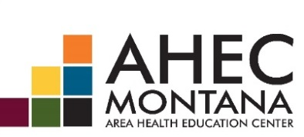

Montana Community Health Worker Dialogue
Thursday, October 22, 2015
1:00 – 3:00 PM
Helena, MT - Disability Rights Montana, Liberty Room
1022 Chestnut St, Helena, MT 59601
Call-in Number: 888-387-8686, 8422675#

Introductions

Review Previous Meeting
- Review Meeting Summary Notes

Environmental Scan
- Review Survey Summary

Next Steps

