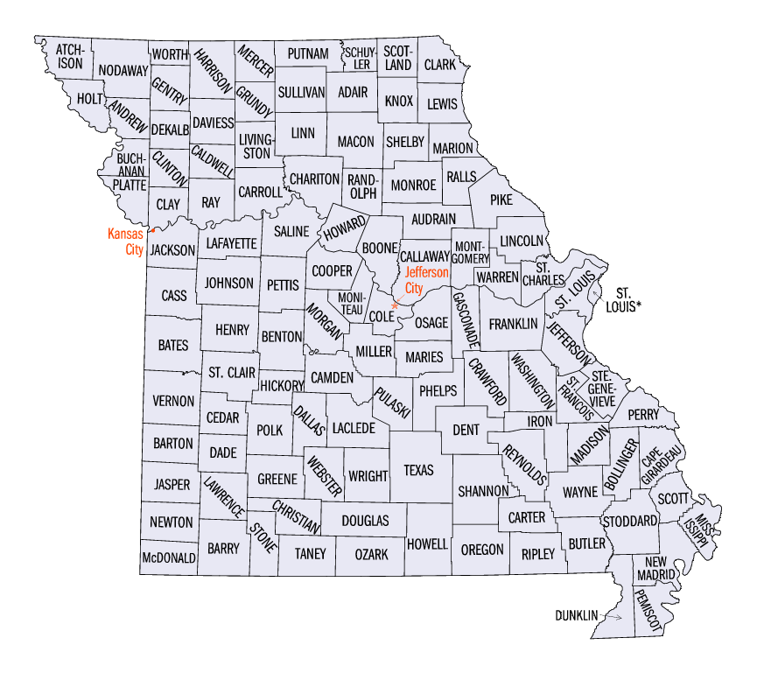

50 Community Health Workers (CHWs) working at 24 Community Health Centers. CHWs are not currently providing services at all CHC locations however organizations hope to expand the number of locations that CHW services are provided onsite as funding allows.

Patients living in multiple zip codes served in Kansas City and Jackson County by KC Care and Swope Health Services

Patients living in multiple zip codes served in St. Louis City and St. Louis County by Affinia Healthcare, Betty Jean Kerr People’s Health Centers, Family Care Health Centers, and Myrtle Hilliard Davis