IDAHO COMMUNITY HEALTH WORKER (CHW) COMMITTEE

Kickoff Meeting
Wednesday, March 4, 2015
9:00 a.m. – 4:00 p.m.
Hilton Garden Inn
7699 W. Spectrum St., Boise

AGENDA

9:00 – 9:30  9:30 – 10:00  10:00 – 10:30  10:30 – 10:45  10:45 – 12:00  12:00 – 12:30  12:30 – 1:30  1:30 – 3:45  (break included)  3:45 – 4:00 | Registration and Refreshments  Introductions and Meeting Overview  Monica Revoczi, Workgroup Facilitator  Interaction International, Inc.  Setting the Stage for the CHW Workgroup  Elke Shaw-Tulloch, Administrator  Division of Public Health  Idaho Department of Health and Welfare  BREAK  CHW Foundations and Background  Carl Rush, MRP  Project on CHW Policy and Practice  University of Texas – Houston  Institute for Health Policy  - Introduction to CHW - definitions, models, etc.  - Social determinants of health  - Benefits, impacts, ROI, and challenges  - Q&A  LUNCH BREAK  CHW Critical Success Factors  Carl Rush  - Best practices and experiences of other states  - Policy support  - Q&A  Workgroup Project Plan  - Review workgroup charter: goals and objectives  - Discuss the CHW definition for Idaho  - Review and discuss draft project plan: milestones, schedule, deliverables  - Discuss CHW key informants and assessment: purpose, content, process  - Identify additional sources of key intelligence  - Introduction to workgroup file share  Wrap Up  - Summarize meeting and accomplishments  - Review and confirm action items/next steps  - Conduct meeting evaluation

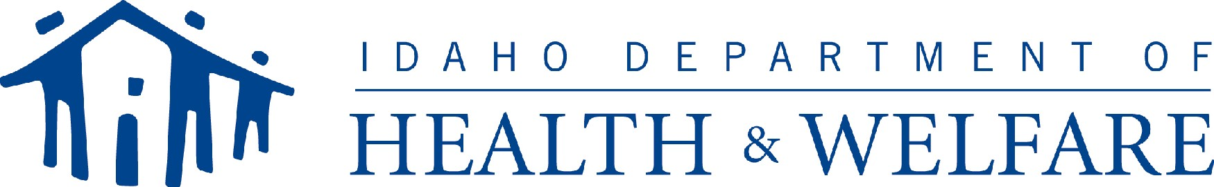
Division of Public Health
Idaho Department of Health and Welfare

